**OPENING MUSIC: How low was our Redeemer brought**

Watch video <https://youtu.be/leC_mPuYja4>

*Please listen to this song*

*as we shall sing it later in the service.*

How low was our Redeemer brought!

The King who held the stars

lay helpless in a maiden’s arms

and pressed against her heart.

While sheep and cattle raised their voice,

the babe could speak no words;

the ever-flowing spring of joy

had come to share our thirst.

How low was our Redeemer brought!

The Lord the worlds obeyed

would stumble as he learned to walk

upon the ground he’d made;

the one the angels bowed before

would kneel to wash our feet

and be at home among the poor,

though he owned everything.

*Gloria, gloria in the highest! (repeat)*

How low was our Redeemer brought

to raise us from our shame!

And now the highest praise of all

belongs to Jesus’ name.

The healer wounded on a tree

to bear our grief and sin;

the King gave up his crown so we

could ever reign with him.

*Gloria, gloria in the highest! (repeat)*

How low was our Redeemer brought

to raise us from our shame!

And now the highest praise of all

belongs to Jesus’ name.

*Matt Boswell, Bob Kauflin, Nathan Stiff & David Zimmer © 2020 Sovereign Grace*

**WELCOME and NOTICES**

**LIGHTING of the ADVENT CANDLE: PEACE**

**CALL TO WORSHIP** *(extracts from Hebrews 1)*

One: Long ago, at many times and in many ways,

God spoke to our ancestors by the prophets.

**All: In these final days,**

**he has spoken to us through his Son.**

One: The Son is the light of God’s glory

and the imprint of God’s being.

**All: After he had accomplished cleansing for sins,**

**he sat down at the right side**

**of the highest Majesty.**

**SONG: Of the Father's love begotten**

Watch video <https://youtu.be/chLMSiozhL8>

Of the Father's love begotten

ere the worlds began to be,

he is Alpha and Omega, he the source, the ending he,

of the things that are, that have been,

and that future years shall see,

evermore and evermore.

He is found in human fashion,

death and sorrow here to know,

that the race of Adam’s children,

doomed by law to endless woe,

may not henceforth die and perish

in the dreadful gulf below, evermore and evermore!

O ye heights of heaven, adore him;

angel hosts, his praises sing;

powers, dominions fall before him,

and extol our God and King;

Let no tongue on earth be silent,

every voice in concert sing, evermore and evermore.

Christ, to thee, with God the Father,

and, O Holy Ghost, to thee,

hymn and chant with high thanksgiving,

and unwearied praises be;

honour, glory and dominion,

and eternal victory, evermore and evermore!

*From* Corde natus, *AC Prudentius (348-410)*

*Tr. HW Baker & JM Neale (Public Domain)*

**PRAYER**

**ALL-AGE TALK**

**SONG: Come, light our hearts!**

Watch video <https://youtu.be/iv2Vyf7R1Wk>

*For You, O Lord, our souls in stillness wait--*

*for You, O Lord, our souls in stillness wait:*

*truly our hope is in You--*

*truly our hope is in You.*

O Lord of life, our only hope,

Your radiance shines

on all who look to You in the dark.

Emmanuel come, come light our hearts!

*For You, O Lord, our souls in stillness wait…*

O Joy above all other loves,

in You we find more than enough.

We come as we are, O heal and restore!

Come, light our hearts!

O Joy above all other loves…

*For You, O Lord, our souls in stillness wait…*

*Sandra McCracken © Integrity Worship Music, Paper News*

**BIBLE READING (Reader: Geoff Dawe)**

**Matthew 1: 18-25**

**(New International Reader's Version)**

**REFLECTIONS: Joseph (The Dreamer)**

**SONG: How low was our Redeemer brought**

Watch video <https://youtu.be/n4HCTQlliD8>

*See OPENING MUSIC for the words.*

**PRAYERS for OTHER PEOPLE and OURSELVES**

**(led by Susan Wong)**

**Our Father in heaven,**

**hallowed be your name,**

**your kingdom come,**

**your will be done,**

**on earth as in heaven.**

**Give us today our daily bread.**

**Forgive us our sins**

**as we forgive those who sin against us.**

**Lead us not into temptation**

**but deliver us from evil.**

**For the kingdom, the power,**

**and the glory are yours**

**now and for ever. Amen.**

**song: Come thou long expected Jesus**

Watch video <https://youtu.be/P8kaePsR68o>

Come, thou long expected Jesus,

born to set thy people free,

from our fears and sins release us.

Let us find our rest in thee.

Israel's strength and consolation,

hope of all the earth thou art;

dear desire of every nation,

joy of every longing heart.

Born thy people to deliver,

born a child and yet a King;

born to reign in us forever,

now thy gracious kingdom bring!

By thine own eternal Spirit

rule in all our hearts alone;

by thine all sufficient merit

raise us to thy glorious throne.

By thine own eternal Spirit

rule in all our hearts alone;

by thine all sufficient merit

raise us to thy glorious throne.

*Charles Wesley (1707-1788) (Public Domain)*

**THE BLESSING**

**CLOSING MUSIC: To thee we run**

Watch video <https://youtu.be/Gu8S6KUwZHg>

When these days of shadow pass

and suffering is no more

a fire in the dark will glow

and Christ our souls restore.

Holy child of mystery,

please set ablaze our hearts

with grace unending, love so pure

and pierce the ancient dark.

*O Light! Heaven shine down on earth!*

*O Joy! Come and break the curse!*

*We praise the name above every name;*

*a light has come and Christ to thee we run.*

As the tide of heaven's wrath

is washed beneath the sea.

A Living Stream shall quench our thirst

for all eternity.

*O Light! Heaven shine down on earth…*

*O Light! Heaven shine down on earth…*

*Eric J. Marshall © 2012 Young Oceans*

*All hymns/songs used on this sheet used by permission:*

*CCL Licence No 974355 Scottish Charity No SC005838*

**Next week: Advent 3**

**PRAYER**

If you would like prayer for anything, members

of the prayer team will be available

at the back of the church at the end of the service.

**CHILDREN’S ACTIVITIES**

If you have childrenwith you today, we have activities for them during the service.

Please ask a welcomer, or listen out for announcements from the front.

**TCC Prayer Meeting**

This evening as usual: 7.15pm in the small hall.

All welcome – just come along.

**PASTORAL CARE**

Please let us know of anyone who would like a telephone call, or a visit at home or in hospital.

**Please phone Margaret Webster on 672347**

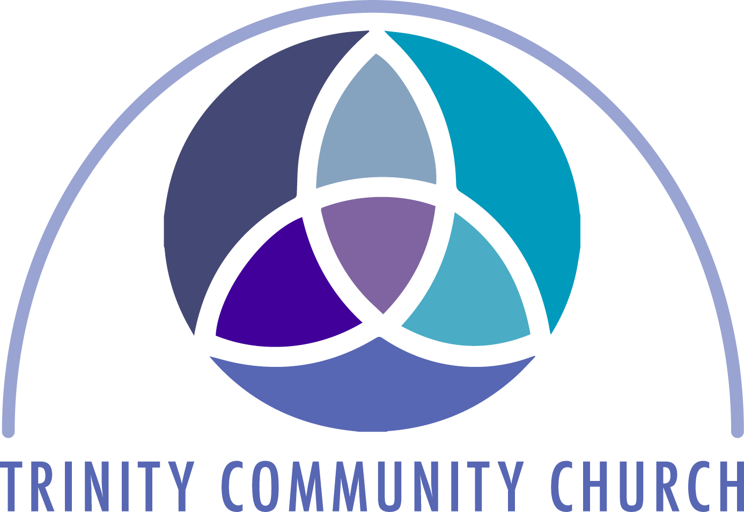**Penicuik Trinity Community Church**

**(Church of Scotland)**

**Sunday 8th December**

**Second Sunday in Advent**



**Whether you come here regularly,**

**haven’t been for a while or are a visitor,**

**we are glad that you can be with us today.**

**Please joins us in the hall**

**for a cup of tea or coffee after the service.**

Church website

[www.penicuiktrinitycommunity.church](http://www.penicuiktrinitycommunity.church/)

**BLUE CHRISTMAS SERVICE**

**Tuesday 10th December at 7.30 pm**

 St James the Less Episcopal Church

The service is for those who may find the Christmas season to be a challenging or difficult time of year, in particular because of bereavement. It will be a time of quiet reflection, led by the Revd Nick Bowry and the Revd Graham Astles. All are welcome.

Refreshments will be served afterwards.

**Tuesday Youth BIBLE group**

**Tuesday 10th December 7-9pm**

**Age group: S1 – S6 (12-17)**

An opportunity for young people to explore who they are, why they matter, and the difference Jesus can make to their lives. For more information contact

Ann Dunsire 076974605590 OR

Andrew Dunsire 07580593504

**CAROL SINGING IN THE PRECINCT**

(Penicuik Churches Together)

**Saturday 14th December 10 – 12 noon**

Come along and join in!

**‘TOWN HALL’ CAROL EVENT**

This year’s Hope for Penicuik Carol Evening

will be held in the **TCC CHURCH HALL**

**on Saturday 14th December 6.30-7.30pm**

For all the family, with Penicuik Silver Band.

**CHRISTMAS AT FFF**

On Saturdays December 14th and 21st –

FFF would be greatly helped if a few volunteers from the churches could go in during the morning till about 2pm to help serve coffees and light lunches and maybe even sing some carols. If you are able to be part of a team on either of these dates please give your name to John or to Joan Cape.

**BLUE CHRISTMAS SERVICE**

**Tuesday 10th December at 7.30 pm**

 St James the Less Episcopal Church

The service is for those who may find the Christmas season to be a challenging or difficult time of year, in particular because of bereavement. It will be a time of quiet reflection, led by the Revd Nick Bowry and the Revd Graham Astles. All are welcome.

Refreshments will be served afterwards.

**Tuesday Youth BIBLE group**

**Tuesday 10th December 7-9pm**

**Age group: S1 – S6 (12-17)**

An opportunity for young people to explore who they are, why they matter, and the difference Jesus can make to their lives. For more information contact

Ann Dunsire 076974605590 OR

Andrew Dunsire 07580593504

**CAROL SINGING IN THE PRECINCT**

(Penicuik Churches Together)

**Saturday 14th December 10 – 12 noon**

Come along and join in!

**‘TOWN HALL’ CAROL EVENT**

This year’s Hope for Penicuik Carol Evening

will be held in the **TCC CHURCH HALL**

**on Saturday 14th December 6.30-7.30pm**

For all the family, with Penicuik Silver Band.

**CHRISTMAS AT FFF**

On Saturdays December 14th and 21st –

FFF would be greatly helped if a few volunteers from the churches could go in during the morning till about 2pm to help serve coffees and light lunches and maybe even sing some carols. If you are able to be part of a team on either of these dates please give your name to John or to Joan Cape.

**BLUE CHRISTMAS SERVICE**

**Tuesday 10th December at 7.30 pm**

 St James the Less Episcopal Church

The service is for those who may find the Christmas season to be a challenging or difficult time of year, in particular because of bereavement. It will be a time of quiet reflection, led by the Revd Nick Bowry and the Revd Graham Astles. All are welcome.

Refreshments will be served afterwards.

**Tuesday Youth BIBLE group**

**Tuesday 10th December 7-9pm**

**Age group: S1 – S6 (12-17)**

An opportunity for young people to explore who they are, why they matter, and the difference Jesus can make to their lives. For more information contact

Ann Dunsire 076974605590 OR

Andrew Dunsire 07580593504

**CAROL SINGING IN THE PRECINCT**

(Penicuik Churches Together)

**Saturday 14th December 10 – 12 noon**

Come along and join in!

**‘TOWN HALL’ CAROL EVENT**

This year’s Hope for Penicuik Carol Evening

will be held in the **TCC CHURCH HALL**

**on Saturday 14th December 6.30-7.30pm**

For all the family, with Penicuik Silver Band.

**CHRISTMAS AT FFF**

On Saturdays December 14th and 21st –

FFF would be greatly helped if a few volunteers from the churches could go in during the morning till about 2pm to help serve coffees and light lunches and maybe even sing some carols. If you are able to be part of a team on either of these dates please give your name to John or to Joan Cape.

**CAROL SINGING**On **Wednesday December 18th**

we are invited to sing carols at Aaron House,

from 2.00pm. If you would like

to be involved with this, please speak to

Joan Cape or John**.**

**SERVICE OF LESSONS AND CAROLS**

**Sunday 22nd December 7pm**

St James the Less Church

Come and join this annual celebration,

with the augmented church choir

**COFFEE AND CHAT at TCC**

**Thursday mornings, 10am till noon,**

in the church hall at the foot of Kirkhill.

All welcome: come regularly or once in a while;

come for 10 minutes, or stay all morning.

**RENEW 26**

Thursdays 2-4pm, Glencorse Centre

Fridays 10am – noon, Penicuik North Kirk

**A quiet shared space where it’s OK not to be OK**

Based around the 5 ways to wellbeing,

to promote good mental and emotional health.

There is a quiet space for prayer and meditation.

Email: [renew26@gmail.com](mailto:renew26@gmail.com)

**BIBLE STUDY/HOUSE GROUPS**

TCC has a number of Bible Study/House Groups,

open to all who are interested. Each has its own way of doing things, but all involve reading a passage of scripture, taking time to discuss it and the questions it raises, in relation to our daily lives. All of these groups would welcome new members, whether new to Bible study or “old hands”. **Full details on the notice board.**

**CAROL SINGING**On **Wednesday December 18th**

we are invited to sing carols at Aaron House,

from 2.00pm. If you would like

to be involved with this, please speak to

Joan Cape or John**.**

**SERVICE OF LESSONS AND CAROLS**

**Sunday 22nd December 7pm**

St James the Less Church

Come and join this annual celebration,

with the augmented church choir

**COFFEE AND CHAT at TCC**

**Thursday mornings, 10am till noon,**

in the church hall at the foot of Kirkhill.

All welcome: come regularly or once in a while;

come for 10 minutes, or stay all morning.

**RENEW 26**

Thursdays 2-4pm, Glencorse Centre

Fridays 10am – noon, Penicuik North Kirk

**A quiet shared space where it’s OK not to be OK**

Based around the 5 ways to wellbeing,

to promote good mental and emotional health.

There is a quiet space for prayer and meditation.

Email: [renew26@gmail.com](mailto:renew26@gmail.com)

**BIBLE STUDY/HOUSE GROUPS**

TCC has a number of Bible Study/House Groups,

open to all who are interested. Each has its own way of doing things, but all involve reading a passage of scripture, taking time to discuss it and the questions it raises, in relation to our daily lives. All of these groups would welcome new members, whether new to Bible study or “old hands”. **Full details on the notice board.**

**CAROL SINGING**On **Wednesday December 18th**

we are invited to sing carols at Aaron House,

from 2.00pm. If you would like

to be involved with this, please speak to

Joan Cape or John**.**

**SERVICE OF LESSONS AND CAROLS**

**Sunday 22nd December 7pm**

St James the Less Church

Come and join this annual celebration,

with the augmented church choir

**COFFEE AND CHAT at TCC**

**Thursday mornings, 10am till noon,**

in the church hall at the foot of Kirkhill.

All welcome: come regularly or once in a while;

come for 10 minutes, or stay all morning.

**RENEW 26**

Thursdays 2-4pm, Glencorse Centre

Fridays 10am – noon, Penicuik North Kirk

**A quiet shared space where it’s OK not to be OK**

Based around the 5 ways to wellbeing,

to promote good mental and emotional health.

There is a quiet space for prayer and meditation.

Email: [renew26@gmail.com](mailto:renew26@gmail.com)

**BIBLE STUDY/HOUSE GROUPS**

TCC has a number of Bible Study/House Groups,

open to all who are interested. Each has its own way of doing things, but all involve reading a passage of scripture, taking time to discuss it and the questions it raises, in relation to our daily lives. All of these groups would welcome new members, whether new to Bible study or “old hands”. **Full details on the notice board.**